## Module 10 Student Questions

## Thought Experiments: How Can We Encode Spatial Information into MR Signal? - Guided Inquiry Questions

*Thought Experiment 1: Consider a sample that is split between two different locations in space and placed in a uniform magnetic field, like the one shown below.*

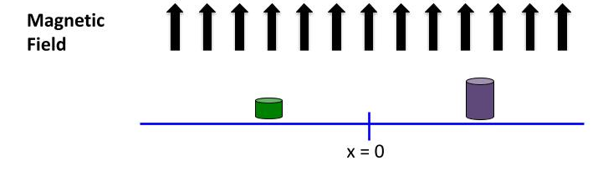

1. Sketch what you think the MR frequency spectrum of this sample would look like. *Hint: Are the Larmor frequencies different for the different bits of the sample?*
2. Would you be able to determine the spatial distribution of the sample from this frequency spectrum?

*Thought Experiment 2: Consider the same sample, but now placed in a known* ***magnetic field gradient*** *- i.e., the magnetic field changes over space (in this case, in a nice linear fashion, as the figure illustrates below).*

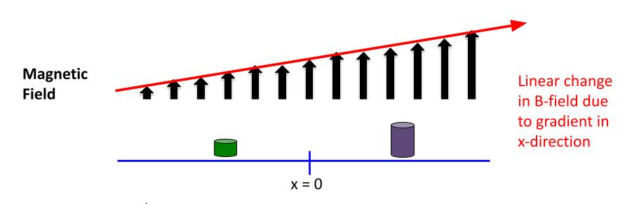

1. Sketch what you think the MR frequency spectrum of this sample would look like now. *Hint: Are the Larmor frequencies different for the different bits of the sample?*
2. Would you be able to determine the spatial distribution of the sample from this frequency spectrum?

## 

## A New Form of Imaging - Guided Inquiry Questions

1. Why do gradients need to be applied in multiple different directions in order to build up a multidimensional image?
2. If we want higher resolution images, would you want to increase or decrease the magnetic field gradient (e.g., have more or less variation of magnetic field strength over space)?
3. A higher resolution image means that each pixel in a 2D image (voxel in a 3D image) contains signal from a smaller and smaller area (volume) in space. What might be some limiting factors for the spatial resolution in MRI?

## 

## How Do We Use Gradients to Create Images? - Guided Inquiry Questions

1. Once you open the [PhET MRI Simulation](https://phet.colorado.edu/sims/cheerpj/mri/latest/mri.html?simulation=mri), you can click on the tab entitled “Simplified MRI” and see something similar to the figure in the margin.

a. What are the red, blue, and white arrows representing? Why do you think they are represented that way?

b. What do the white block arrows represent? Is the magnetic field being shown homogeneous or inhomogeneous?

1. Check out the "Radiowave Source" control panel at the bottom.

a. What is "Power" controlling?

b. What is "Frequency" controlling?

1. Play around with the controls to determine (roughly) the resonant frequency of the system (without changing any of the magnetic field controls on the right).

a. Describe what happens at this resonant frequency.

b. Using the magnetic field strength given on the right side and the table provided in the margin, what nuclei do you think we are detecting?

1. Check out the control panel on the right side.

a. Describe what happens when you turn up the gradient in the horizontal direction. Where does the magnetic field strength get weaker? Where does it get stronger? Where does it stay the same?

b. Describe what happens when you turn up the gradient in the vertical direction. Where does the magnetic field strength get weaker? Where does it get stronger? Where does it stay the same?

1. Set the frequency of the radio wave source to 42.5 MHz, the main magnet to 1.2 T, and the power of the radiowave source to 100%.

a. What can you adjust so that only the atoms at the top of the head resonate?

b. What can you adjust so that only the atoms in the ear on the left resonate?

*Now let's go tumor hunting!* A "tumor" in this simulation is an area where there is a high density of atomic nuclei. To make this slightly more realistic, unclick "show atomic nuclei". You now only have the frequency, magnetic field, and gradient controls to isolate the location of the tumor by looking at the detected signal.

1. Describe a procedure you can use to identify an approximate location for the tumor.
2. Click the "Add tumor" button in the lower right corner and use your procedure to attempt to find the approximate location of the tumor.

a. Which quadrant of the head do you think the tumor is located?

b. After you have made your best attempt to find the tumor, reclick “Show atomic nuclei.” Were you correct about its location?

1. Based on what you have seen in the simulation, how might scientists build up an image using the controls provided?

## 

## Modern-Day Imaging - Guided Inquiry Questions

1. On the MRI (A, B, C) and CT (D) images below, give the name of the specific plane that each image was taken from and suggest which region of the body is shown.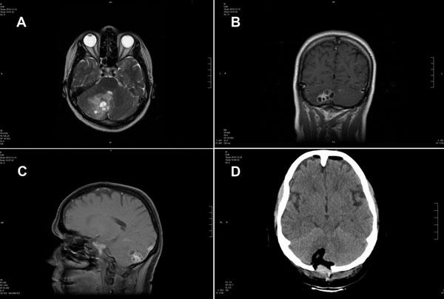

## What Provides Contrast in Imaging? - Guided Inquiry Questions

1. The easiest way to decipher which type of imaging sequence was used in an MRI image of the brain is to look at the signal intensity of cerebrospinal fluid (CSF) in comparison with the gray matter of the brain.

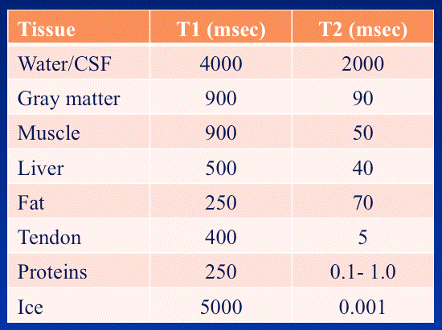

a. The CSF looks much darker than the gray matter in the T1-weighted image. Why is that the case?

b. The CSF looks much brighter than the gray matter in the T2-weighted image. Why is that the case?

1. Look carefully at the fMRI image shown in the margin.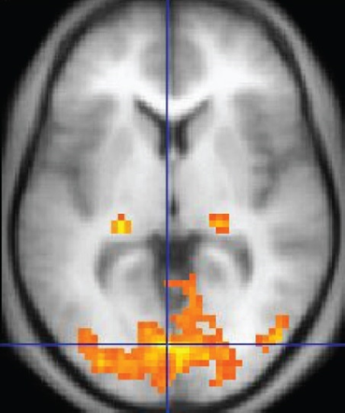
   1. What plane was the image taken from?
   2. What type of imaging sequence (PD, T1 weighting, T2 weighting) do you think was used for the background?
   3. Why might different blood oxygenation levels provide contrast in MRI images?
2. What are the possible advantages of adding contrast media, compared to the other image contrast mechanisms discussed?

## Reflection Questions

1. In the history of MRI given in the text, what were some obstacles that Lauterbur and Mansfield had to overcome for MRI to be widely accepted?

2. MRI is almost predominantly looking at 1H in blood, soft tissues, and other bodily fluids. Provide possible MR and biological reasons for using 1H instead of another nuclear isotope.

3. The images in question 16 are of the brain of a 51-year-old woman infected with tapeworm larvae. The MRI images were taken using T1 weighting (A), T2 weighting (B), using a contrast agent (C), and then the final image (D) was made using a CT scan post-operation after the larvae were removed. Why do you think these doctors used these different imaging modalities for diagnosis and post-operation imaging?

4. Using what you understand about MR and have learned about MRI in this module, what are some potential limitations and challenges for MRI?

**Follow this rubric to assess your work for this module:**

| **Scientific Ability** | **Adequate** | **Needs improvement** | **Inadequate** | **Missing** |
| --- | --- | --- | --- | --- |
| **Is able to explain the importance of magnetic field gradients for encoding spatial information in MR signals** | Correctly explains the importance of magnetic field gradients for encoding spatial information in a comprehensible way. | Some minor errors or unclear portions of the explanation. | A large portion of the explanation contains errors or is incorrect. | No attempt is made to explain the importance of magnetic field gradients for encoding spatial information in MR signals. |
| **Is able to identify key differences between MRI and other imaging modalities** | Identifies at least three correct key differences between MRI and other imaging modalities. | Identifies at least two correct key differences between MRI and other imaging modalities. | Only identifies one correct key difference between MRI and other imaging modalities. | No attempt is made to identify key differences between MRI and other imaging modalities. |
| **Is able to utilize prior knowledge about MR signals to determine different ways to provide contrast to an MR image** | Successfully utilizes correct and relevant prior knowledge to determine different ways to provide contrast to an MR image. | An attempt is made to utilize prior knowledge, but some small errors are made. | An attempt is made to utilize prior knowledge, but it uses incorrect information or information not relevant to providing contrast to an MR image. | No attempt is made to use prior knowledge to determine ways to provide contrast to an MR image. |